Student Name | G. Manasa
Student Registration Number | 241U1R3007 | Class &Section: CSE(DS)
Study Level: UG/PG | UG | Year &Term: I & II
Subject Name | Startup Management

Name of the Assessment | Reflective Journal -9
Date of Submission | 07-09-2025

Reflective Journal Template
Journal Entry Guidelines | Description
1. Experience (Class Content) | Briefly describe the topics or concepts discussed during the class.
2. Feelings (Emotional Reactions) | Share your emotional reactions and thoughts during the class.  How did you feel while learning this theory?  Did the class evoke specific emotions or questions?
3. Learning (Key Insights) | Reflect on what you learned from the class.  Highlight the key insights or fundamental concepts you gained from the class.
4. Application (Practical Use) | Describe how you plan to apply the theory you've learned in real-life situations or in your academic/career endeavours.  Explain the practical utility of this theory.

Sample Journal Entry

Date | 07-09-2025
Journal Entry Topic | Create your company profile
1. Experience (Class Content) | In this module, I learned how to create a company profile and make a sales plan using the customer acquisition funnel. I also learned how to choose the right key number metric to track sales and practiced making a sale with the help of a clear positioning statement. One of the best parts was preparing a sales pitch, which helped me improve my speaking and convincing skills. Uploading screenshots of my venture website gave me real experience of connecting theory with practice. I also understood that sales are not just about directly asking a customer to buy. It is a step-by-step process. The funnel showed me how businesses first create awareness, then build interest, move to consideration, and finally convert into a sale. Another learning was the importance of tracking sales with numbers like conversion rate or retention rate. this module gave me both knowledge and practice. It improved my understanding of sales, customer engagement, and communication. I now feel more confident to use these skills in real life for a startup idea, project work, or even my future career.
2.Feelings (Emotional Reactions) | At first, I felt a little nervous because creating a sales plan and company profile seemed challenging, but as I moved through the steps, I started enjoying the process. I felt excited while preparing the sales pitch and happy to see how my ideas could be presented clearly. I felt confident and motivated after completing this module.
3. Learning (Key Insights) | I learned how to make a company profile that explains the vision, mission, and goals of a business. I understood the customer funnel – first creating awareness, then interest, then consideration, then sales, and finally keeping the customer. This showed me that sales are not one step but a process of trust. I also learned that checking key numbers like sales growth, conversion rate, or customer retention is important to see if the plan is working. I understood that a good sales pitch should be short, clear, and solve customer problems. This made me more confident in communication. I realized that strong customer service and follow-ups are also important. Uploading my venture website screenshots gave me real practice and showed how websites can attract and help customers.  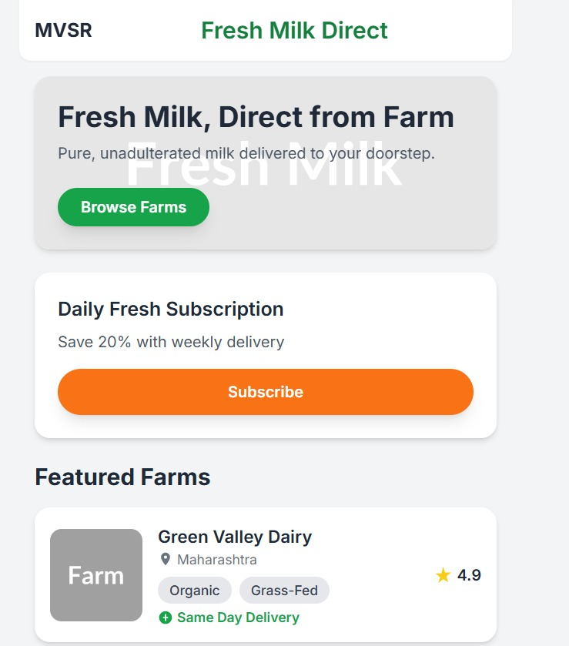
4. Application (Practical Use) | - I can use the sales funnel idea in any small business or project to understand customer behavior.  - The sales pitch skills will help me in presentations, interviews, and future entrepreneurship.  - Knowing how to track key metrics will help me in monitoring progress, whether in academics, projects, or even personal goals.  - Creating a company profile is similar to preparing a good CV or LinkedIn profile, so it will also help me in career growth.  - Understanding how to present products online through a website is a practical skill that I can use in today’s digital world.
Conclusion | This module taught me how to think and act like a real business person. I learned that sales is not just about asking people to buy but about understanding their needs, guiding them through a process, and giving them reasons to trust your product. I also realized that planning and tracking progress is very important. I felt proud after completing this module because it gave me both knowledge and confidence. It showed me that with the right steps – profile, funnel, metric, sales pitch, and website – I can present any idea in a professional way. Overall, this experience was very useful for me as a student and will also help me in my career and future projects.

